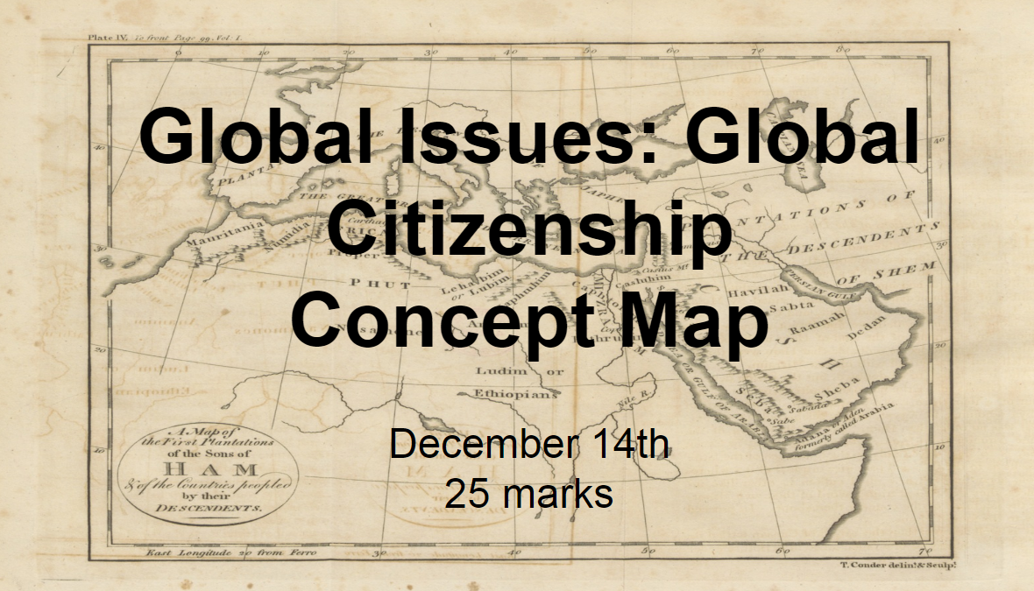
The main goal of writing a concept map is to synthesize the information from the content we have explored together, to make logical connections to different areas in the unit, and relate them to each other, and the main topic: global citizenship. For this reason, you will be allowed to use your resources (notes, charts, articles) as reference.
You will be required to keep detailed and complete notes. Please DO NOT ask me for all the “stuff you missed” the day of review. It is your responsibility to keep track of what you missed. There is a website that has all the lessons, videos, and links to articles for your convenience. Jalexander26.weebly.com
You will complete the concept map on December 14, 2018 during class (unless you have already made arrangements with me).
I will provide the topics that you will be writing about. You do not have to come up with them on your own. The topics will be based on our class lessons such as: Communitarianism vs. Cosmopolitanism, Events after 9/11, or consumerism for example.

The Concept Map Assignment is worth 25 marks.

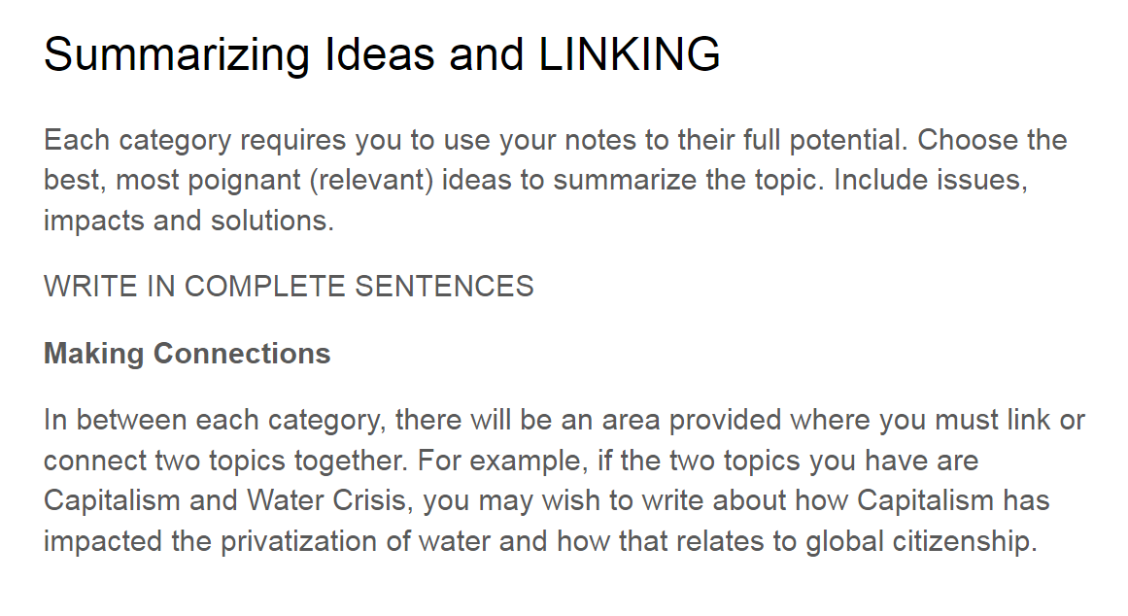

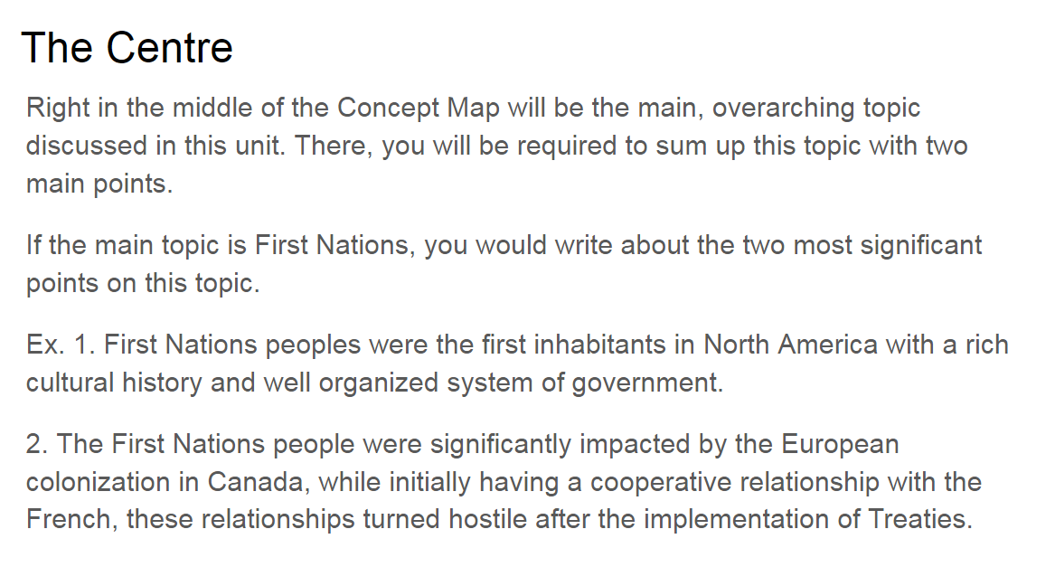
An example of a concept map that earned full marks on the topic of First Nations People in Canada.
