Global Issues: Consumerism
_______________________________________________________________________

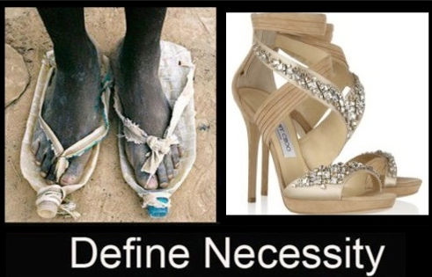
What are basic needs are what is luxury?

Happiness, a short film by Steve Cutts

The Consumer Class

A group of people whose lifestyles are characterized by the accumulation of non-essential goods.

According to data from Worldwatch Institute
(Worldwatch Institute is a globally focused environmental research organization in Washington, D.C.)

Impacts of Globalization: From Luxuries to Necessities

